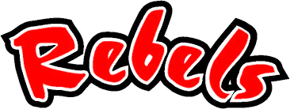
Maryville High School
Swim Meet Schedule 2021-2022
* Diving Team included

MHS v. Science Hill at Green Meadow Pool Sunday, October 31 at 3:00 pm (Warm-ups)
Tentative MHS/MMS Black & Red Intra-squad Meet at Green Meadow Pool Sunday, November 7 Details TBD
MHS v. Bearden High School at Green Meadow Pool Sunday, November 21 at 12:15 pm (Warm-ups)
MHS/MMS v. Oak Ridge High School/Middle School at Oak Ridge Civic Center Tuesday, December 7 at 5:45 pm (Warm-ups)
MHS/MMS v. Farragut HS/MS at Green Meadow Pool Sunday, December 12 Allan Jones, UT at 1:00 pm (Warm-ups). Meets held in two separate courses at the SAME time, not combined.
Ray Bussard Invitational Saturday, December 18 at AJAIC (Allan Jones), U.T., details TBA
MHS v. West High School at Green Meadow Pool Sunday, December 19 at 12:15 (Warm-Ups)
*KISL City Meet Championships Friday-Saturday January 21-22 at AJAIC (Allan Jones), U.T., details TBA
*TISCA State Swimming & Diving Championships Friday-Saturday, February 11-12 at Centennial Sportsplex, Nashville details TBA

